ReadMe

BIRDSCAPE Group Members:

Jordan Green - ST10083222 (Team Leader)

Mishra Mohammed - ST10083182

Daylin Shadrach - ST10083296

Cameron Pillay - ST10083199

**Demo Video: Youtube Link:**

<https://www.youtube.com/watch?v=1Gpar4-3_IE>

* BIRDSCAPE - A bird watching app that was designed and created with the goal of allowing its users to track, figurately capture and view said captured birds.

Description ~ BIRDSCAPE is a user-friendly mobile app designed for bird enthusiasts and nature lovers. Whether you're a seasoned birder or just starting your birdwatching journey, BIRDSCAPE is your go-to companion for an immersive birding experience.

**How to Install and Run the Project:**

**Android Studio Project Code ~**

Step 1

* Ensure that one’s computer has the capabilities to operate Android Studio

* Ensure one has the necessary space to download the application.

* Check the required necessary system requirements

Step 2

* Install Android Studio Electric Eel | 2022.1.1 (Jan 2023) or Android Studio Flamingo | 2022.2.1 Patch 2 (May 2023) (which is the latest version of Android Studio)

*Visit <https://developer.android.com/studio?gclid=CjwKCAiA0syqBhBxEiwAeNx9N_SIDsG_iasqU7bofmIQgWWOW4LpcGCVj7Bbpztvarfbkn3_E9apPRoCcIgQAvD_BwE&gclsrc=aw.ds> to install Android Studio

Step 3

* View and carefully read and identify the terms and conditions of installing Android Studio.

Step 4

* Start coding and have FUN!!! 😊

Step 5

* Download project code from GitHub by searching for our GitHub repository link

Step 6

* Open Android Studio, click on open project, and navigate to the folder which contains developed code

* You have now accessed our BIRDSCAPE Android Studio.

**#** **Key Features:**

* **User Registration and Login:**
* Create your personalized BIRDSCAPE account or log in with ease.
* Your account allows you to keep track of your bird sightings and access your saved data.
* **Interactive Map:**
* BIRDSCAPE integrates a dynamic map feature that enhances your birdwatching adventures.
* With your permission, the app retrieves your location, so you can explore bird hotspots nearby.
* **Discover Bird Hotspots:**
* Easily locate birdwatching hotspots on the map.
* Explore popular birding areas or discover hidden gems for bird sightings.
* **Save Bird Sightings:**
* BIRDSCAPE lets you record your bird sightings with a few simple taps.
* Capture bird names, and even add photos to create a personal birdwatching journal.
* **View Your Birding History:**
* Access your bird sighting history at any time.
* Review past sightings, share them with fellow birders, and track your progress as you continue your birdwatching journey.

**Why BIRDSCAPE?**

* **Connect with Nature:** BIRDSCAPE brings you closer to the wonders of the natural world. Explore the avian diversity in your area and beyond.
* **User-Friendly Interface:** The app is designed for all levels of birdwatchers, from beginners to experts. Its intuitive design ensures a seamless and enjoyable experience.
* **Community Sharing:** Connect with a community of fellow birders, share your sightings, and discover new species based on shared experiences.
* **Educational Resource:** BIRDSCAPE is a valuable educational resource. Learn more about birds, their habits, and habitats through our integrated database.

**Download BIRDSCAPE today and embark on a journey of discovery as you observe, record, and share your birdwatching experiences.**

Images:  
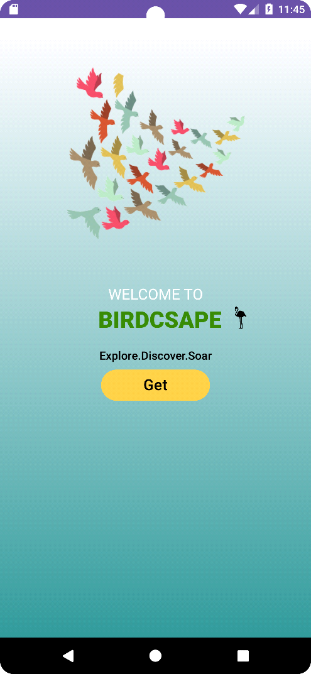 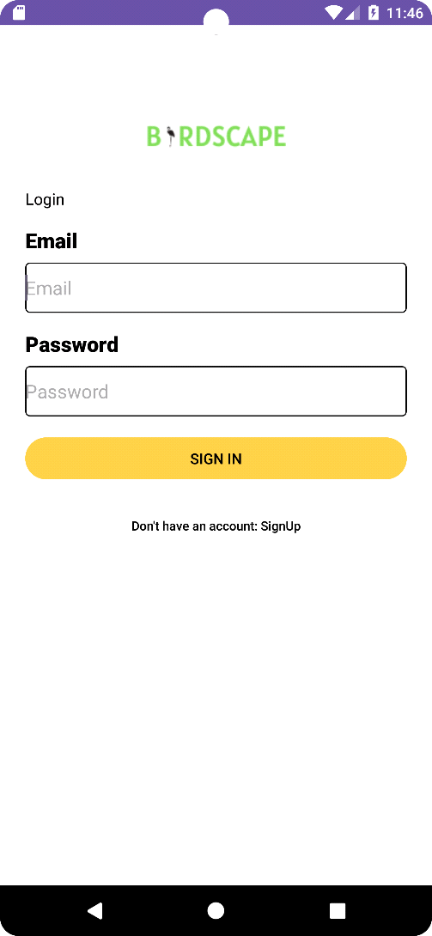

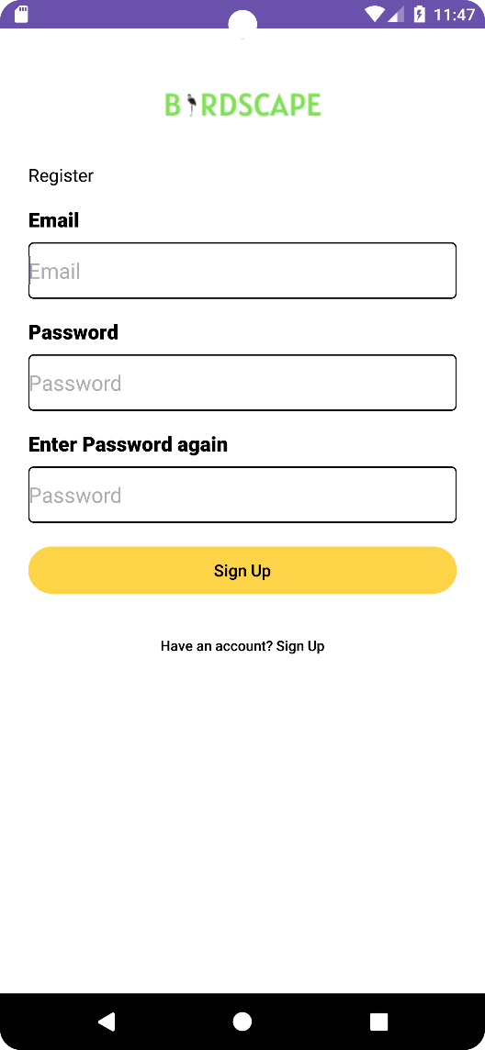 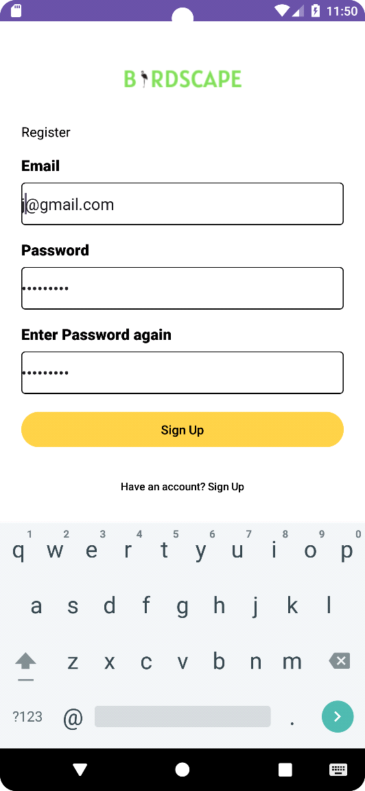

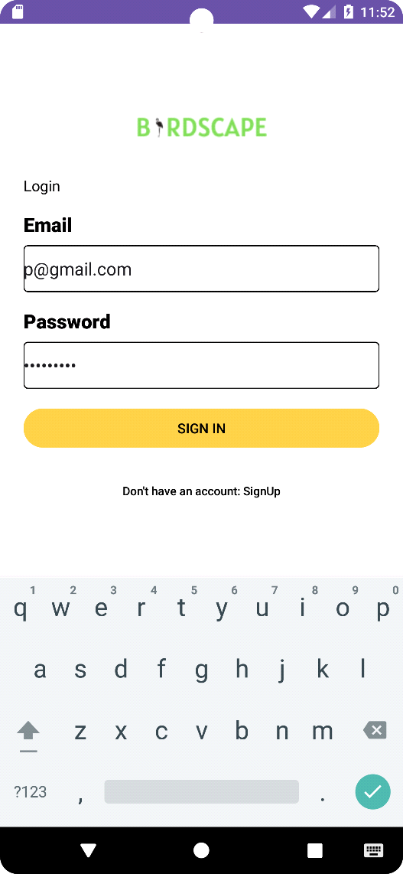 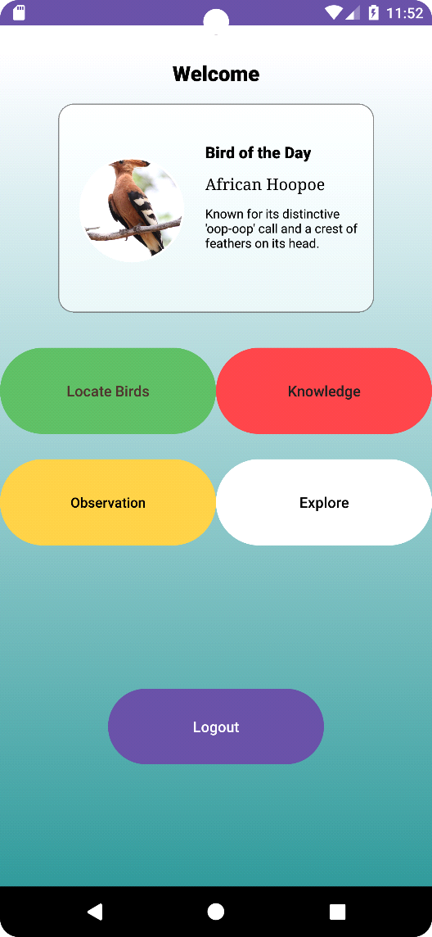

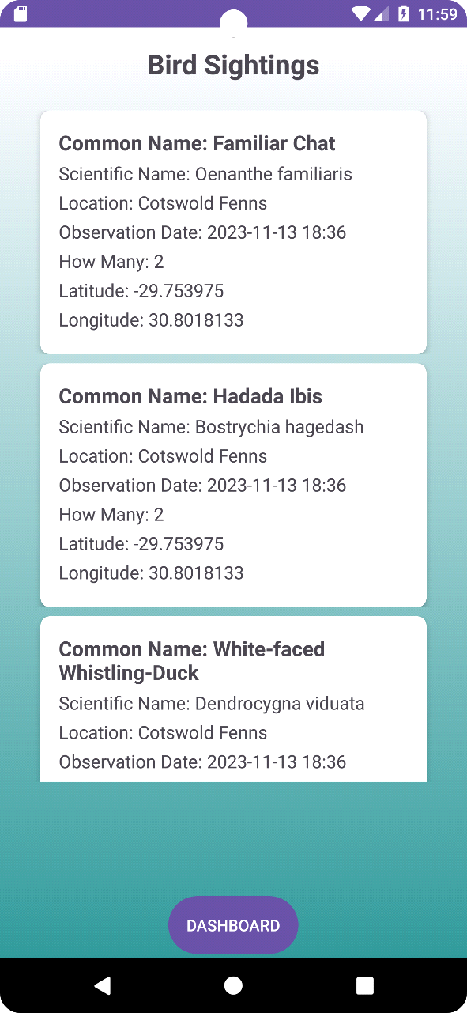 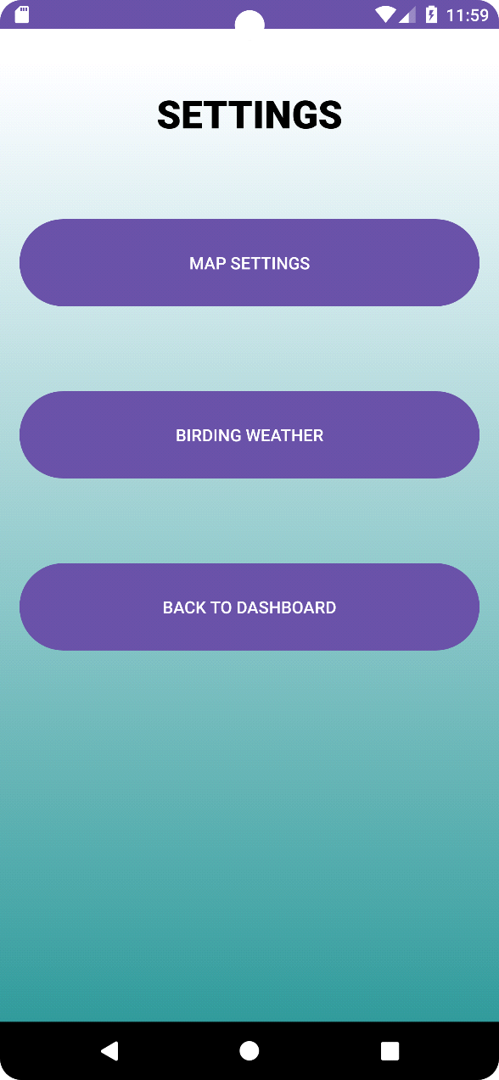

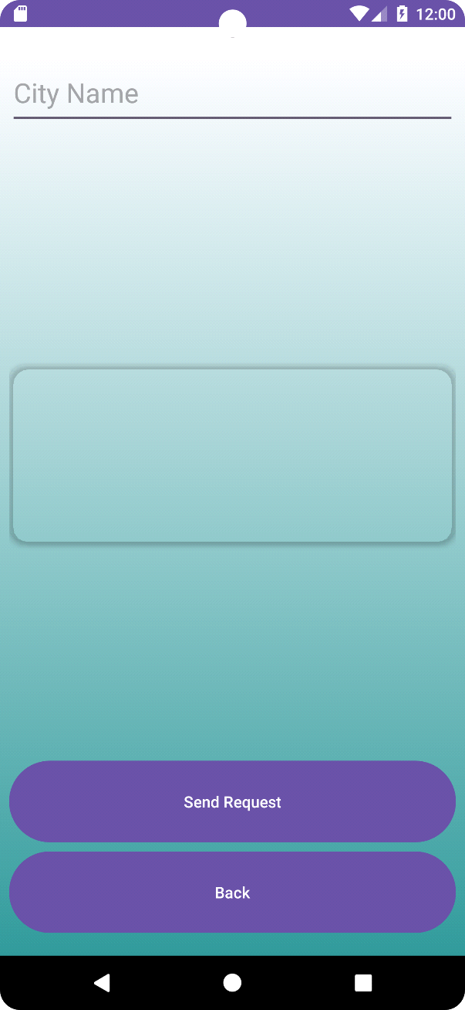 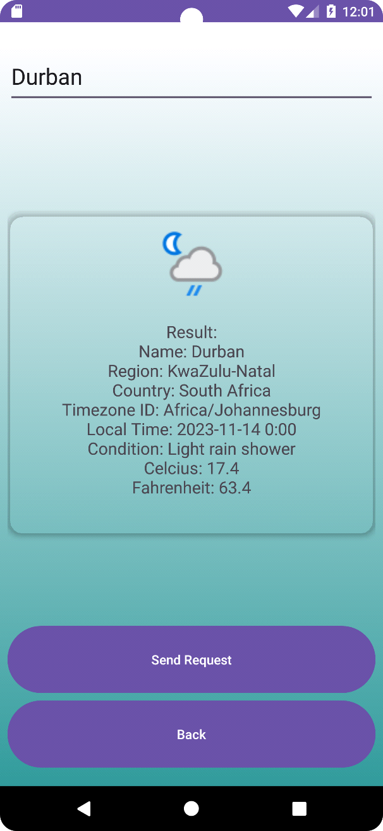

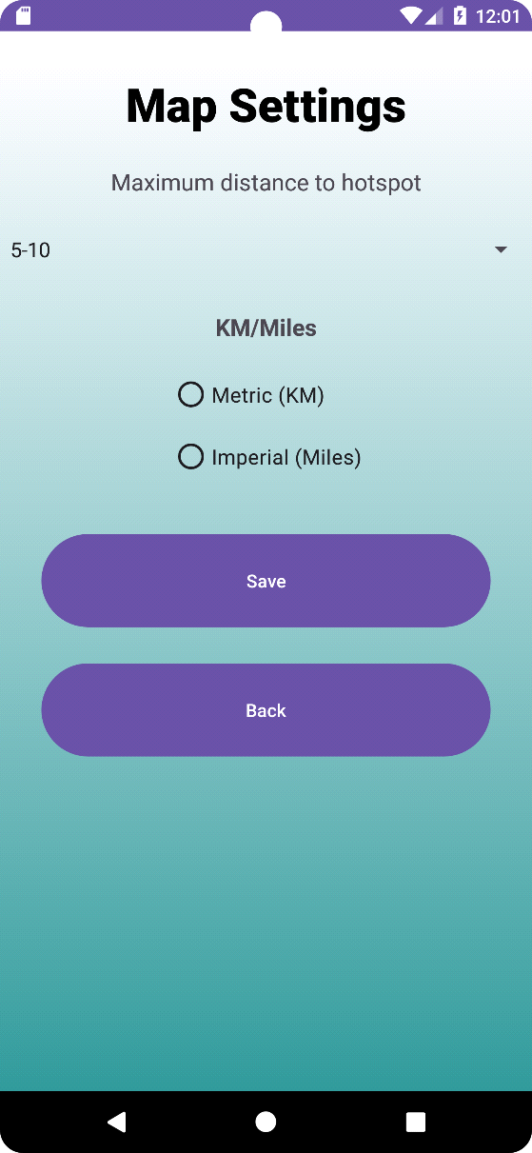 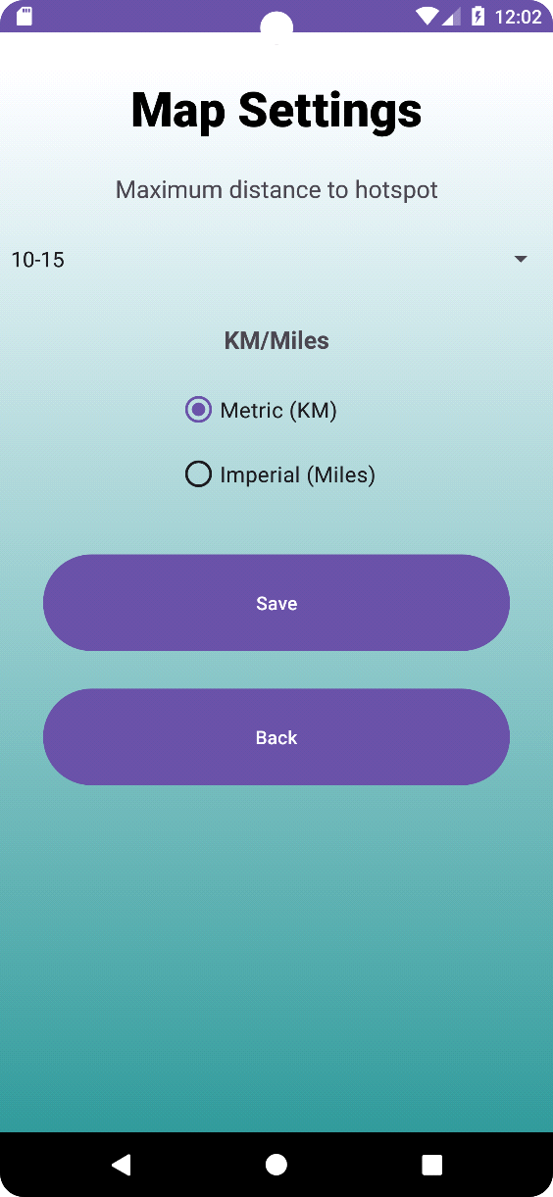

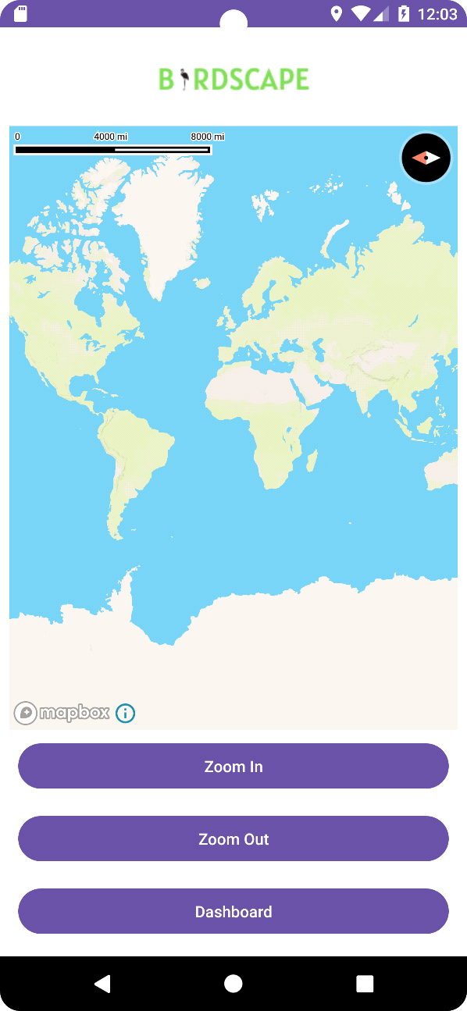 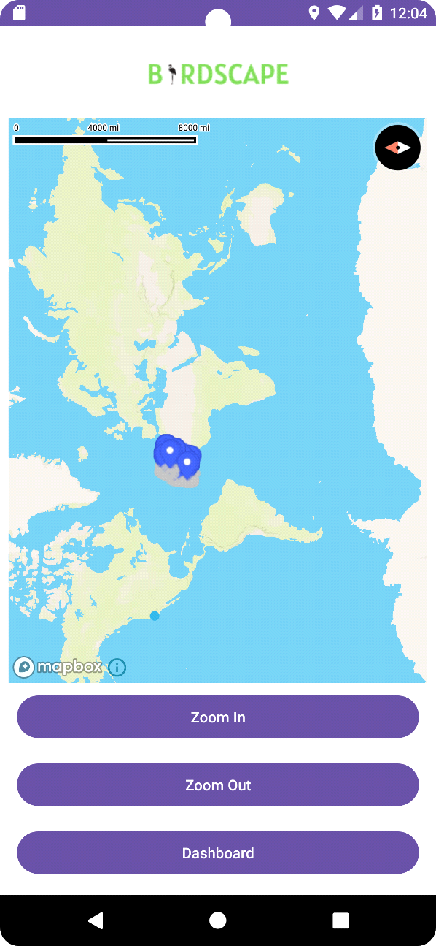

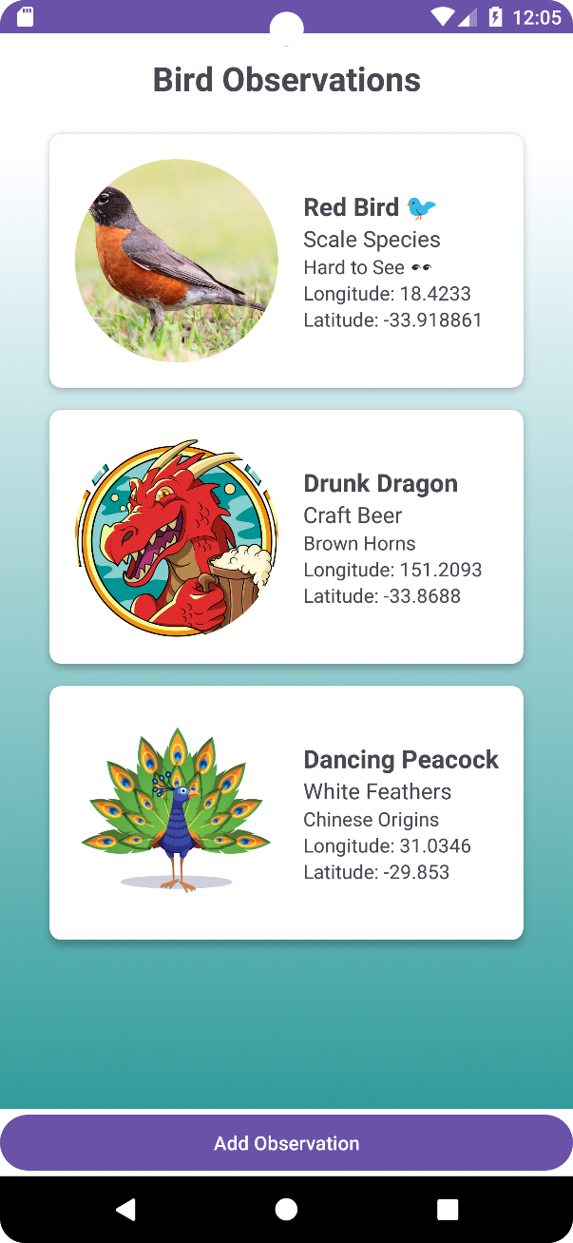 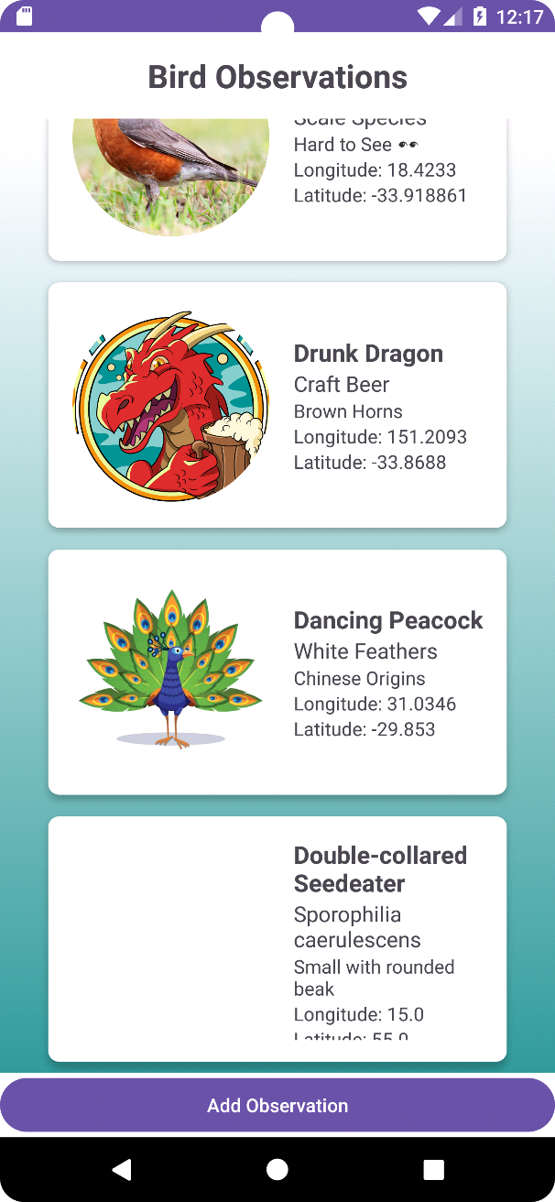

Error features:

- The team faced struggles trying to implement user navigation as we have attempted to extensively include it as we have added the code functionality to the project.

- We also provided the action of adding a bird hotspot to the map display, it works correctly in adding it, however it does not operate cohesively as we intended.

- The team initially had issues for the settings page, however the functionality works as intended.

Publishing Birdscape App to the Google Play Store:

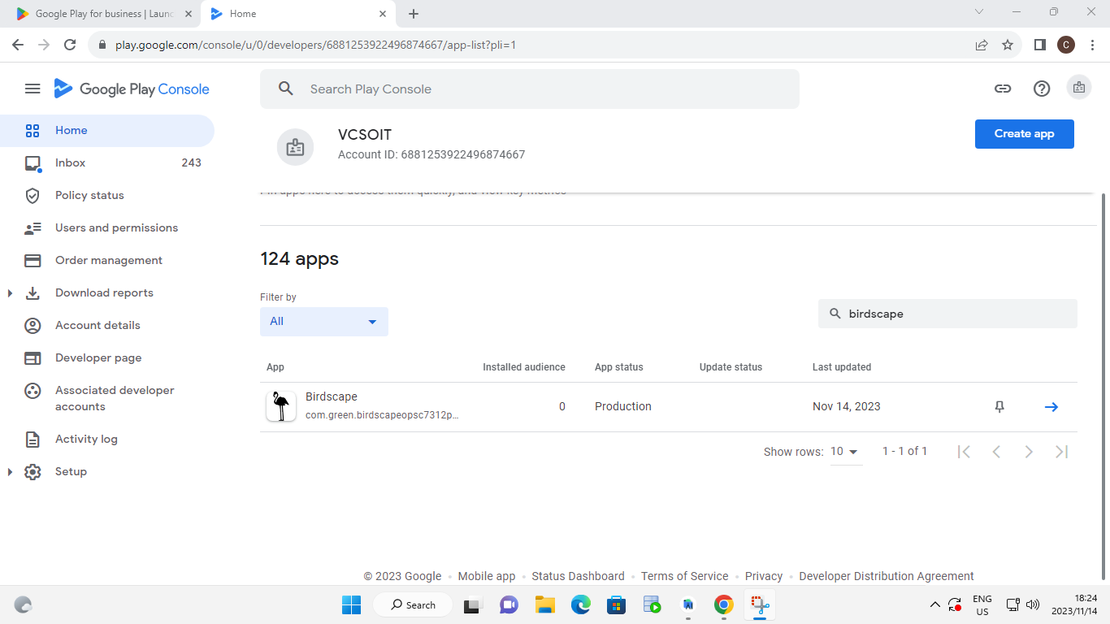

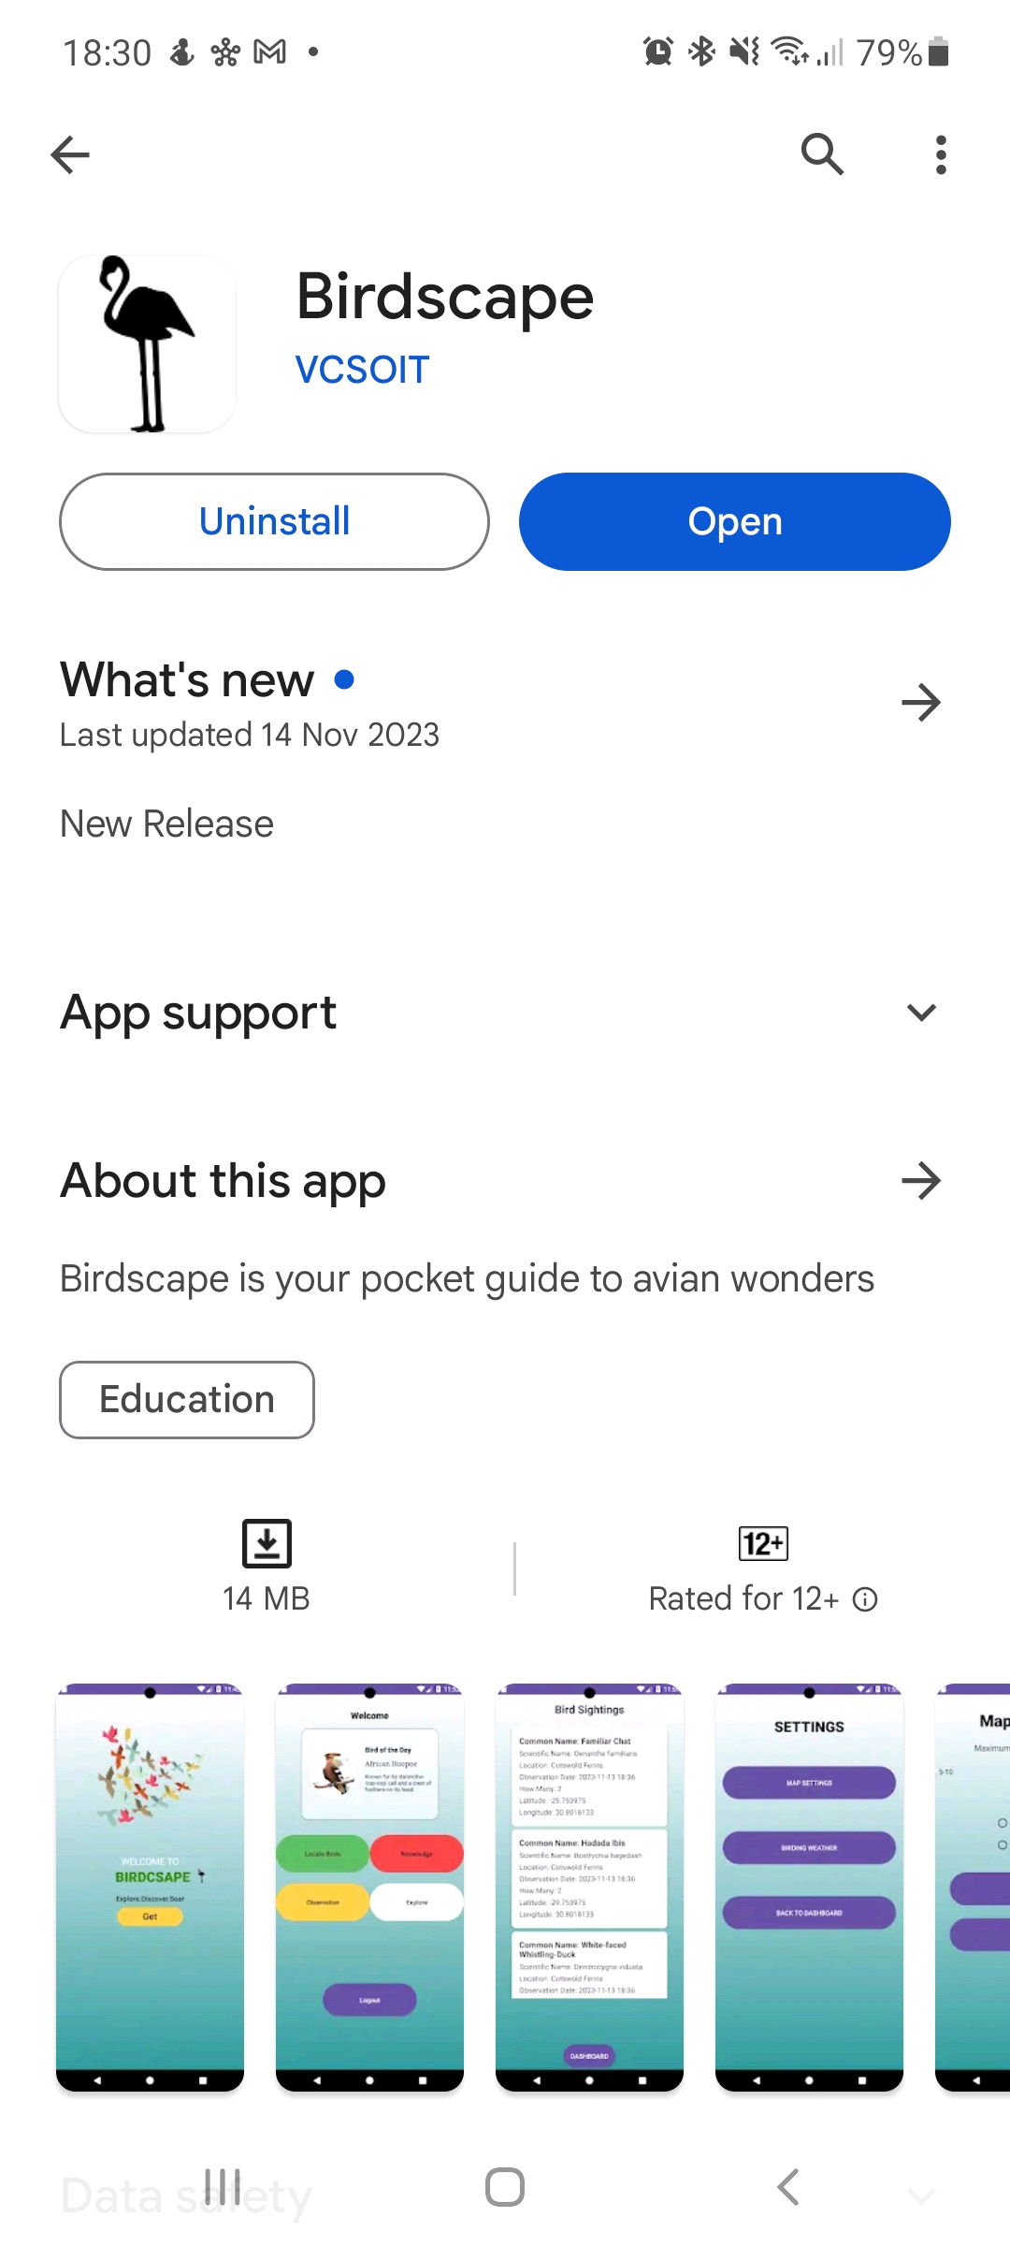

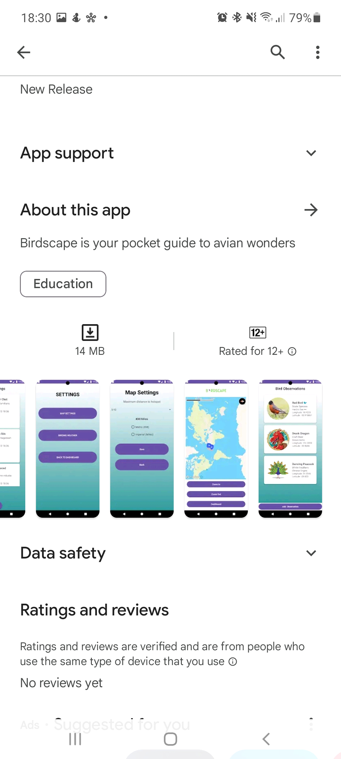

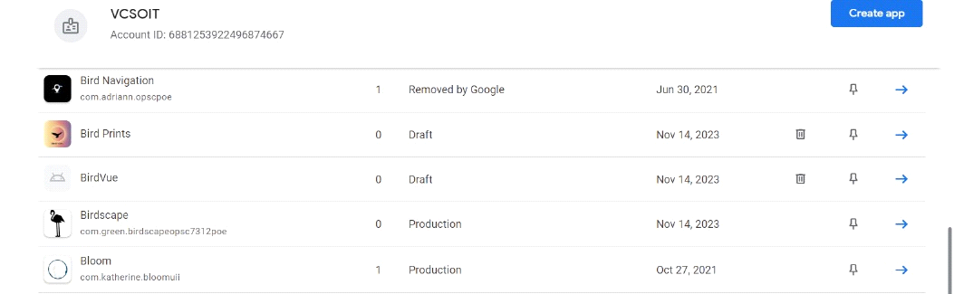

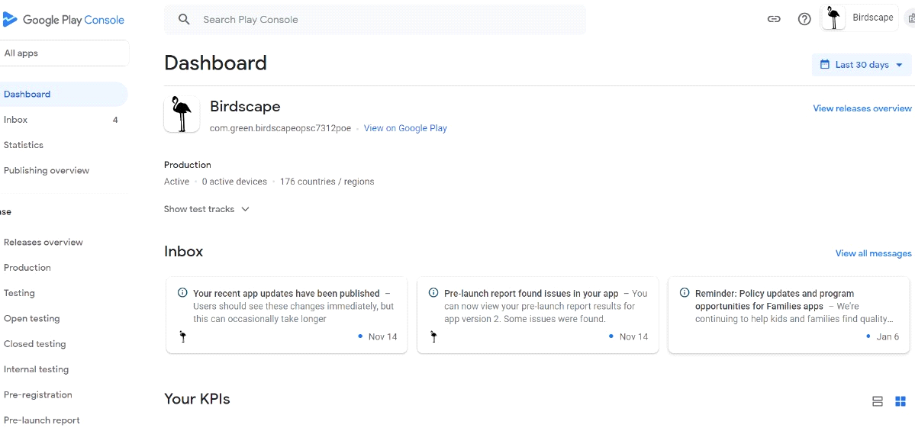

Google Play Dashboard link to Birdscape App: <https://play.google.com/console/u/0/developers/6881253922496874667/app/4975887420357426628/app-dashboard?timespan=thirtyDays>

**References**

* Mapbox. (n.d.). Android Turn-by-Turn Navigation. Retrieved October 18, 2023, from <https://docs.mapbox.com/android/navigation/guides/turn-by-turn-navigation/>
* iFresHD. (2016, May 3). Android Studio Tutorial - Google Maps Directions API [Video]. YouTube. <https://www.youtube.com/watch?v=iEpX-pkepKU>
* Code City. (2019, May 26). Android Google Maps - Drawing Route Between Two Points [Video]. YouTube. <https://www.youtube.com/watch?v=lAckLFH7mIE> Simplified Coding. (2018, January 24). Android Google Maps Drawing Route | Fetching Distance and Duration [Video]. YouTube. <https://www.youtube.com/watch?v=DDEBhPVKuRY>
* EDMT Dev. (2017, July 28). Android Google Maps Direction API - Google Maps Nearby Places [Video]. YouTube. <https://www.youtube.com/watch?v=kMrsk4tbZ7Q>
* Mapbox. (n.d.). Mapbox GL Directions Example. Retrieved October 18, 2023, from <https://docs.mapbox.com/mapbox-gl-js/example/mapbox-gl-directions/>
* Gupta, R. (2018, October 22). Haversine Formula to Calculate Distance between Two Points in Haversine Formula - Calculate Geographic Distance on Earth. iGIS Map. <https://www.igismap.com/haversine-formula-calculate-geographic-distance-earth/>
* Mapbox. (n.d.). Android Fetch a Route Example. Retrieved October 18, 2023, from <https://docs.mapbox.com/android/navigation/examples/fetch-a-route/>
* Raja, S. (2017, October 12). Android Kotlin Tutorial - Google Maps [Video]. YouTube. <https://www.youtube.com/watch?v=FKDyAdYVQ2c>
* Garg, A. (2021, January 23). Login and Registration in Android using Firebase in Kotlin. GeeksforGeeks. <https://www.geeksforgeeks.org/login-and-registration-in-android-using-firebase-in-kotlin/>
* Raja, S. (2017, October 16). Android Kotlin Tutorial - Get Current Location | Android Studio [Video]. YouTube. <https://www.youtube.com/watch?v=hurcmk_4QCM>
* Agarwal, P. (2020, May 4). Get Current Location in Android Studio using Kotlin. Techpassmaster. <https://techpassmaster.com/get-current-location-in-android-studio-using-kotlin/>
* Smith, J. (2022). Amazing Nature Documentary. Retrieved from <https://youtu.be/p0nhM5irW7Y?si=EZxkt8ta74oLfOfI>. Accessed on October 18, 2023.
* Save Data in Firebase Realtime Database using Kotlin | Realtime Database | Kotlin | Android Studio. 2021. YouTube video, added by Foxandroid. [Online]. Available at: <https://www.youtube.com/watch?v=MFcMw9jJA9o> [Accessed 13 November 2023]
* How to Retrieve Data from Firebase Database using Kotlin | Realtime Database | Kotlin. 2021. YouTube video, added by Foxandroid. [Online]. Available at: <https://www.youtube.com/watch?v=EMM_3Wld2jU> [Accessed 13 November 2023]
* Mapbox docs. Display the user’s location. [Online]. Available at: <https://docs.mapbox.com/android/maps/examples/location-tracking/> [Accessed 13 November 2023]
* Web API Android Studio Kotlin Tutorial | REST. 2022. YouTube video, added by Code With Cal. [Online]. Available at: <https://www.youtube.com/watch?v=hurcmk_4QCM> [Accessed 13 November 2023]
* W3<a/>. Android Intents. [Online]. Available at: <https://www.w3adda.com/android-tutorial/android-intents> [Accessed 13 November 2023]
* GeeksforGeeks. How to Send Data From One Activity to Second Activity in Android?. [Online]. Available at: <https://www.geeksforgeeks.org/how-to-send-data-from-one-activity-to-second-activity-in-android/> [Accessed 13 November 2023]
* AbhiAndroid. Retrofit Tutorial With Example In Android Studio [Step by Step]. [Online]. Available at: <https://abhiandroid.com/programming/retrofit#gsc.tab=0> [Accessed 13 November 2023]
* Wisodewo. D. Fetch data from API in Android Studio (Kotlin) using Retrofit with MVVM Architecture, Medium. [Blog]. Available at: <https://medium.com/@dimaswisodewo98/fetch-data-from-api-in-android-studio-kotlin-using-retrofit-with-mvvm-architecture-4f6b673f6a28> [Accessed 13 November 2023]
* Mapbox Docs. Route generation. [Online]. Available at: <https://docs.mapbox.com/android/navigation/guides/turn-by-turn-navigation/route-generation/> [Accessed 13 November 2023]
* Mapbox Docs. Turn-by-Turn Navigation. [Online]. Available at: <https://www.mapbox.com/use-cases/turn-by-turn-navigation> [Accessed 13 November 2023]
* Mapbox Docs. Display navigation directions. [Online]. Available at: <https://docs.mapbox.com/mapbox-gl-js/example/mapbox-gl-directions/> [Accessed 13 November 2023]
* Sharma, A. 2023. How to upload an app to google play store, *appinventiv*, 13 June 2023. [Blog]. Available at: <https://appinventiv.com/blog/how-to-submit-app-to-google-play-store/> [Accessed: 14 November 2023].